Harvesting Faith
Games Setup
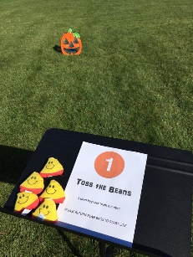
# 1 - Toss the Beans
Pumpkin board (Available at Oriental Trading or Amazon)
Bean bags at start line
Tape line – 8’ – 10’ from board
Sign on stand
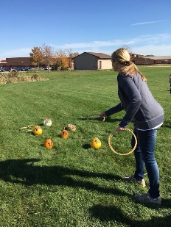
POINTS: on pumpkin board

#2 - Ring the Pumpkin
6 pumpkins with #s – scatter with lower points closer, higher points farther
5 rings at start line (cross stitch hoops work well for tossing)
Tape line – 5’-6’ from closest pumpkin
Sign on stand
POINTS: write on pumpkins, by 5, 10, 15, 20, 25 (higher points for longer throws)

#3 - Pass the Ball (Use a croquet set for this game)
4 hoops in ground – first one 5’-6’ from start line, add 2’ with each _____
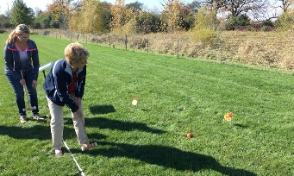
4 balls at start line _____ 25
Mallet _____ 20
Tape line _____ 15
Sign on stand 10
POINTS: on hoops ____________________________
Use decorative paper Start line

#4 - Bowl ‘Em Over
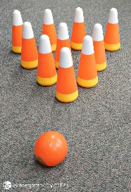
Candy corn bowling pins and ball
Available at Oriental Trading or Amazon
Option: Painted empty soda bottles for pins and squash for the ball
Sign on table
POINTS: per pin knocked down

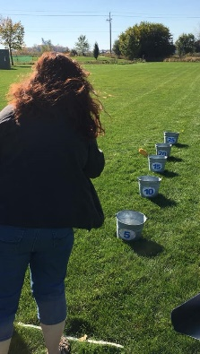
#5 - Corn Cob Toss (Gourds work too!)
5 buckets with points taped on sides Start
Bucket with corn cobs at start line line 5 10 15 20 25
Sign on stand
POINTS: on bucket, use decorative paper

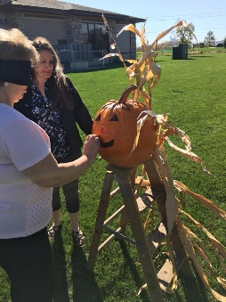
#6 - Pin the Schnoz
1 large pumpkin with face drawn on it
Blindfold
Paper cut-out noses with tape or glue dots
POINTS: on the nose is 25, eyes or mouth is 20
anywhere within the face is 15, and 10 points
outside of the face

#7 - Spin & Play or Pick & Play
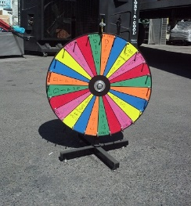
Spin wheel or bucket with slips of paper

IDEAS FOR PROMPTS
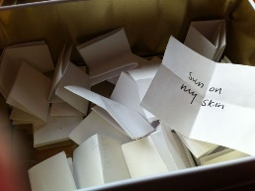
(spin wheel spaces or slips of paper)
- Hop on one foot
- Touch your toes
- Sing a song i.e. Jesus Loves Me
- Hug your teammates
- Tell one person in your group one thing you like about them
- Whistle a tune
- Reach in a bag and guess what’s in it
POINTS: give points for each for difficulty, by 5, 10, 15, etc.

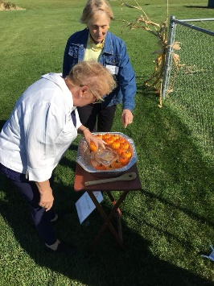
#8 - Pick-a-pumpkin
Large container of water
Mini pumpkins (plastic available on Amazon, or real ones)
POINTS: write the points on bottom of each pumpkin with
a waterproof marker, by 5, 10, 15, etc.

Enjoy the fellowship!

