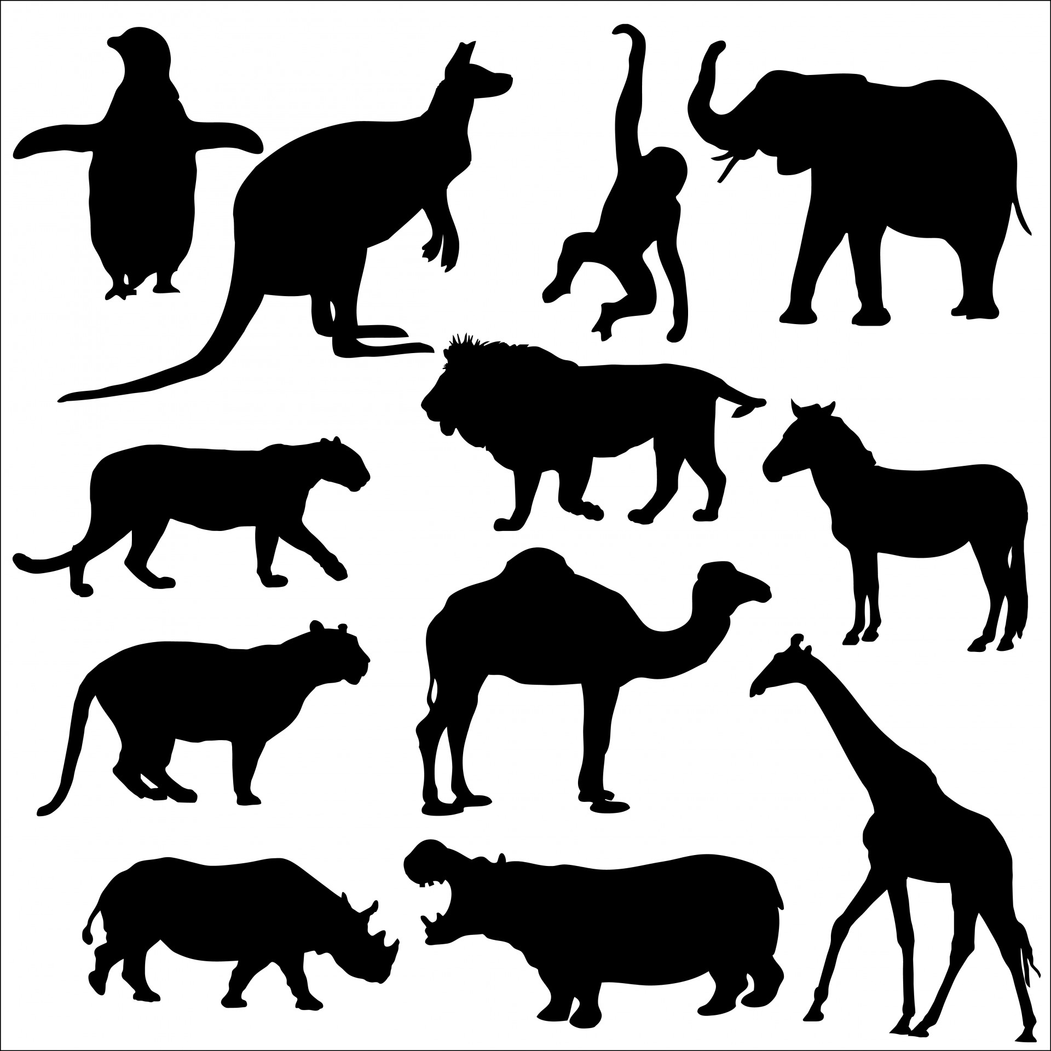

Lion

Tiger

Rhino

Hippo

Giraffe

Zebra

Camel

Elephant

Monkey

Penguin

Leopard

Kangaroo